Implementing Delete:

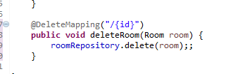

In the data.service.ts class

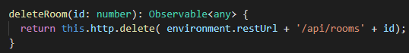

Delete button is in the room-detail-components.ts

Add the message, the binding, and event emitter

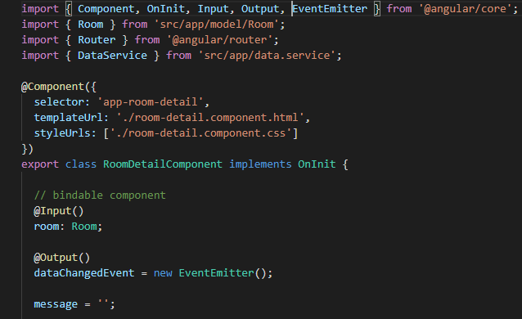

Now, edit the delete method

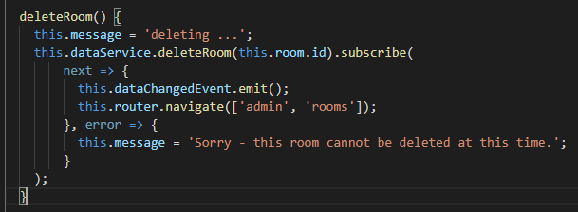

Now in the room-detail.component.html



Now, bind the method in the rooms-component.html (dataChangedEvent)



Now, delete the main conference room

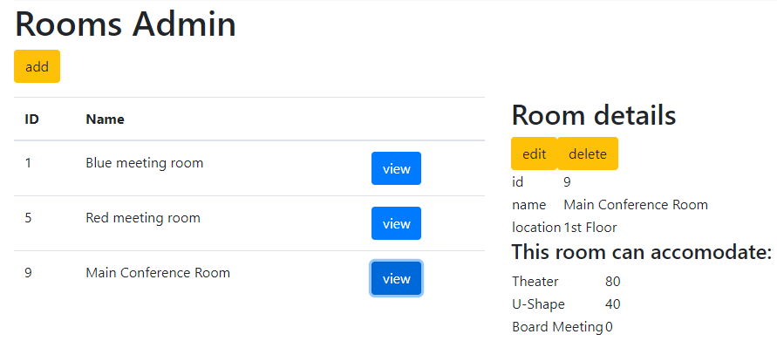

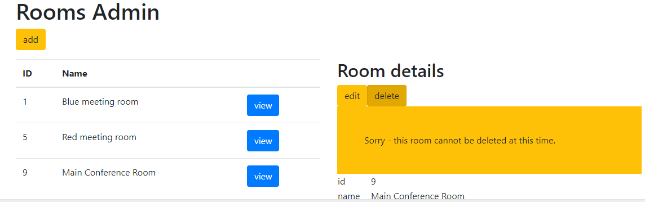

This room must either have an error or have a booking associated with it

Fix the Original method:

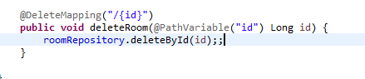

Restart the server and try again.

Fixed the url in the data.service.ts class Needed a / after rooms

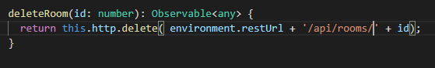

This worked!!

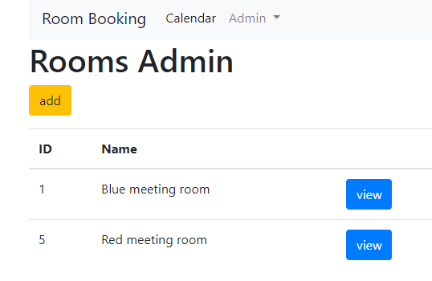

**Delete Users and reset passwords:**

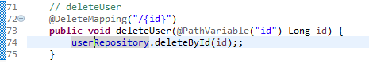

Now setup the Spring Rest call to reset the password

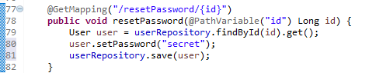

Now in the data.service.ts class implement the rest calls in angular (typescript)

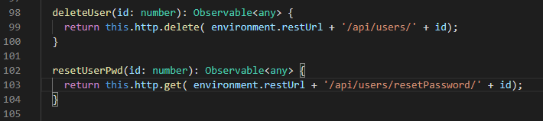

The UI calls these methods in the user-detail.component.ts a child of a parent user.component.ts

Start with the binding Event

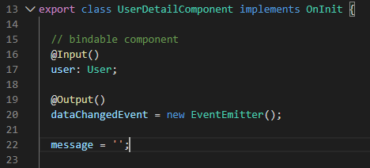

The correct imports:

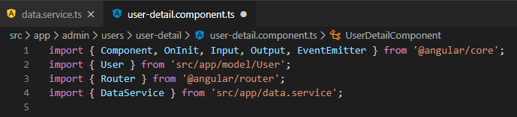

Implement the delete method

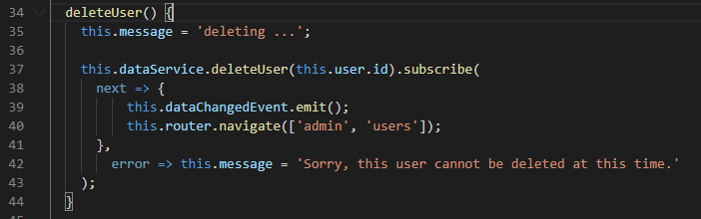

Implement the resetPassword method

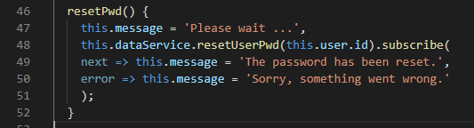

Now, the Html page updates: These are done on the user-detail-component.html page

Display the message:

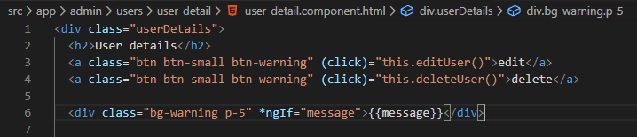

Now, bind the event to the parent, the User-component.html

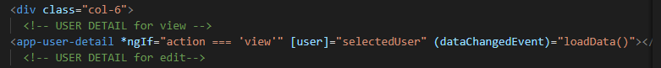

Now, let us test the changes

We should add a new user that we can manipulate first:

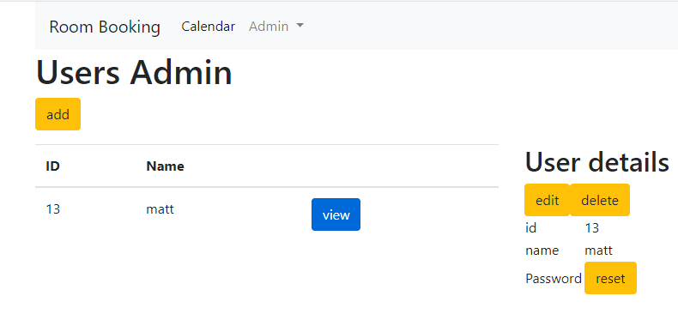

Create paul with password 123:

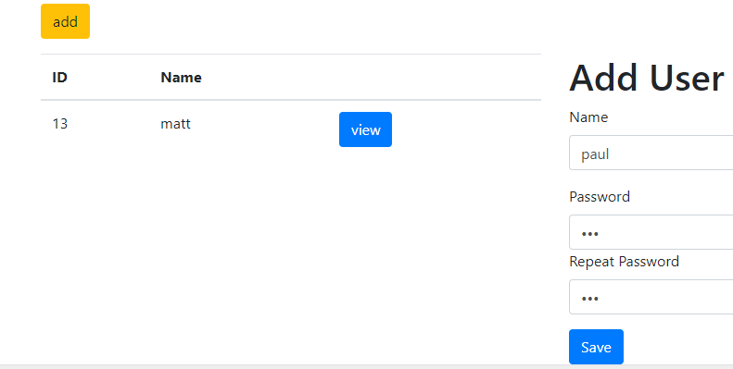

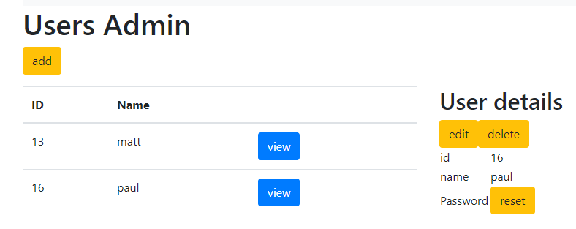

Got a problem with the password reset:

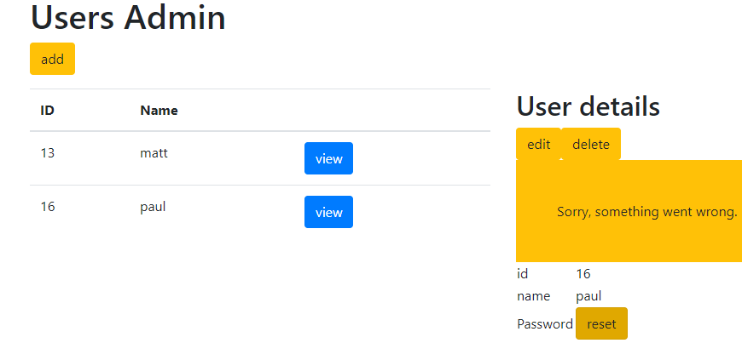

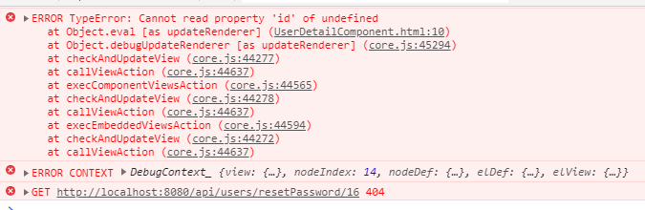

Need to fix this:

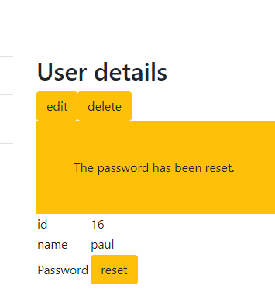

Changed the resetPwd() method name to match the REST application as resetPassword()

User-Detail-Component.ts

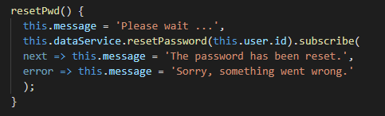

And changed the method name in the dataService

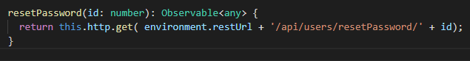

This fixed the reset Password issue: